**Audio Amplifier**

|  |  |
| --- | --- |
| Author | Nikita Pan |

Content

1 Introduction 1

2 Material and methods 2

3 Results 2

3.1 Subtitle 1 2

3.1.1 Subtitle 2

3.1.2 Subtitle 2

3.2 Subtitle 2 2

3.2.1 Subtitle 2

3.2.2 Subtitle 2

4 Discussion 2

5 Reference list 2

# Introduction

The project in this application note is creating a 60-Watt audio amplifier. It is an audio amplifier with a power of 60W that can perfectly be used for car-audio, smartphones and more. This amplifier can be found in the 2017 magazine of elektor, which is a community in the field of electronics to create projects. The reason this amplifier is in this application note is because it is a small, discreet and low-cost design with an excellent sound quality.

The topics discussed in this application note are: the introduction, the materials & methods and the results. After the introduction it is going to be about which materials and which methods or software programs have been used during this project. The last chapter is about the final results of the project, the schemes, the designs and its function.

# Material and methods

This chapter explains more about all the components and software programs that are used in this project. There are a lot of different components involved in making the audio amplifier. There are resistors, capacitors, inductors, semiconductors and miscellaneous. Not only are there several components used during this project, but there also is a number of software programs used to complete the project. The programs that are used during this project and more information about Altium Designer and AutoCAD will be provided later on.

When talking about hardware material or components, the first thing that comes up is a resistor, a capacitor, ... Since the project is delivering a power of 60W, which creates heat there needs to be a solution for the heat. At an output power of 60 W, the output transistors in TO220 housing are going to be very warm. Therefore, good cooling is essential and overload protection is necessary. Good cooling for the transistors is important so an essential heatsink is needed that can properly capture the heat. According to several experiments, researchers found that a heatsink with a value of at least 0.4 K/W is needed to cool down the transistors with a TO220 housing. Now the question is how to connect the heatsink to the transistors. To assemble the heatsink together to the transistors, heat-conductive epoxy glue is needed. It may not look neat, but it is good for cooling the power transistors (see figure 2).  [1]

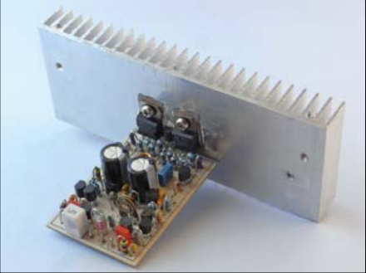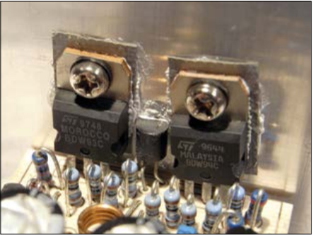

Figure 1 Figure 2

The PCB or printed circuit board is also needed to solder the components onto. This PCB is made using the Altium designer program (see figure 3). To make this PCB in Altium a schematic with all the components is needed first. Then turn the schematic scheme into a PCB scheme using the Altium functions. To complete the PCB scheme place each component on the place where it should be. After this is done neatly without errors, the PCB schematic is ready to be sent to the company to finalize it. The AutoCAD program is used to make an own creative and original logo and housing design for the self-made PCB (see figure 4).

Figure 3

Figure 4

The only characteristics of the components that are compared are the size of the component and viewing if it is a through hole component or an surface mounting device (SMD). In this project there are no surface mounting devices used, but only through hole components. There is also a price difference between 2 identical through hole components, but the difference between them is not the value, but how much power they can handle. The decision between the 2 components that were chosen was made quickly, because the one that can take the most power is the safest for this project.

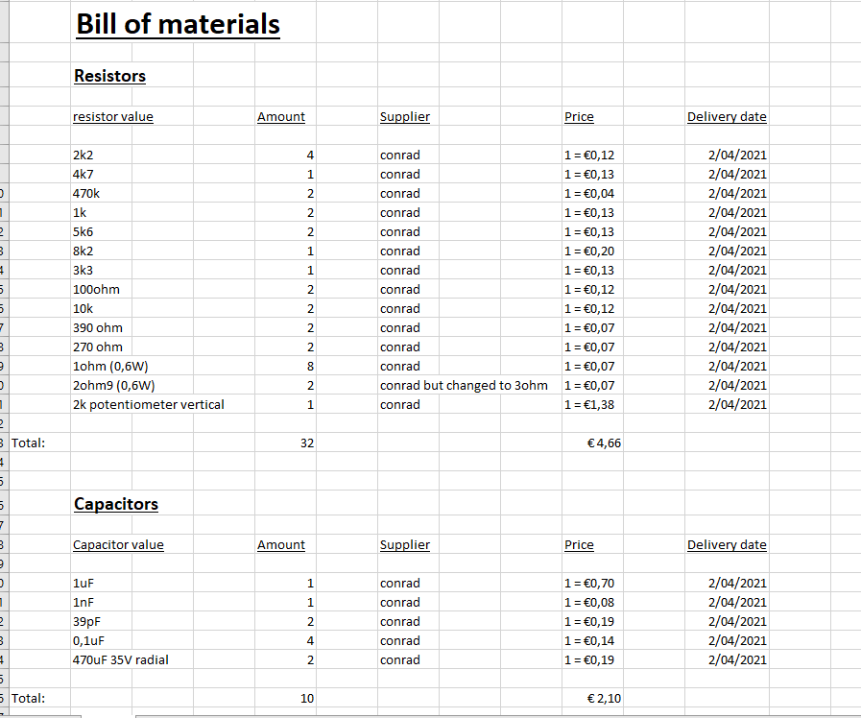The following screenshots include the information about the bill of materials. It consists of a lot of information such as the quantity of a certain value component, the price, the supplier and the delivery date. To know certain values for the semiconductors, datasheets are involved. It contains a lot of information about the component. For example, values of how much voltage and current an LED, diode or transistor can handle. These values are important to know in order to avoid short circuits.

Figure 6

Figure 5

Figure 5

Figure 7 is a schematic representation of the audio amplifier that is made in Altium. The design process started from the input of the scheme which can be seen on the left. After placing the input, the components were built up to the output which is the speaker on the right.

# Results

[Describe the end result you accomplished.

* Describe every aspect of your device. How does it function?
* Add an image of the electrical schematic, PCB design, finalized mechanical design, and finalized product

Write a well-structured text using subtitles and paragraphs.

**+/-500**]

## How does it function?

### Summary

In this part, it will go about all the aspects of this device. The majority of the components and why it belongs in this project will be explained further. As mentioned in the intro, the audio amplifier is built as cheaply as possible, while still maintaining its sound quality. The circuit is made around transistors, the BDW93C/94C Darlington’s which are low priced, but with a good power ratio. Figure 7 is a symmetrical design with smart solutions to reduce the number of parts/components, in such a manner that the price but also its quality has been considered. [1]

### Function

First, the amplifier itself reversed polarity, meaning that it is inverted. The amplifier reverses polarity, because inverting amplifiers operate at a lower rate to correct the open loop phase shift better than not-inverting amplifiers. The input capacitor with a value of 1uF has multiple functions in this circuit. It not only provides the alternating current coupling, but also at the same time the direct current amplification will be reduced by one time. If the amplifier was not inverting, all kinds of issues would arise, such as occurring drift and DC offset issues. Because all frequency-dependent components are kept outside the feedback loop, the signal handling is taken care of by the existing input network and saves a few extra components. [1]

The amplifier works apart from two 39pF capacitors that provide frequency compensation and essential power supply decoupling. Amplifiers used to be made with a low input sensitivity, common for line outputs. This is also how this amplifier was designed. Currently, these line outputs are not used anymore and the headphone outputs and USB-C outputs with low signal level are used more. The damping factor is mainly used at lower frequencies, since it is necessary when using low frequencies. The LEDs in this circuit are used because they have less noise and a lower temperature drift than zener diodes. For the output transistors, 1Ω resistors are used in parallel as emitter resistors for lower self-inductance. The advantages by setting the output transistors to a low quiescent current are: less energy loss and the possibility to drive the output stage with transistors in uncooled TO92 housing. [1]

Because 60W power is used, proper cooling and overload protection is required. In the topic of materials and methods, the part of cooling is fully explained. More attention is now being put on the overload protection. Figure 8 below shows that there is sufficient margin for inductive and lower than recommended speaker loads with a single circuit and setting. This setting is determined by the load of the amplifier and Safe Operating Area specifications of the power transistors. [1]

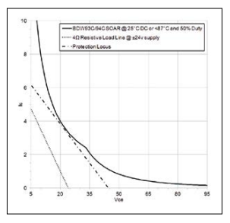

Figure 8

A usual unstabilized power supply suffices with a 100 VA 18-0-18V transformer, a bridge rectifier and two 100mF elco capacitors can be used for the audio amplifier. The supply lines must be protected with 2A fast fuses. [1]

## Finalized product

In the materials and methods topic, Figure 7 is the electrical schematic. Figure 3 is the PCB schematic and Figure 4 is the logo design as mechanical design. The housing of the casing is outlined in Figures 9 and 10. The finalized product is a prototype in Figure 11.

Figure 11

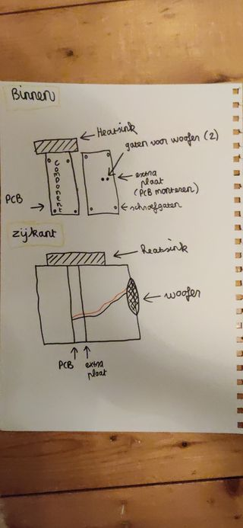

Figure 10

Figure 9

# Discussion

[Reflect on and discuss your project.

* Which difficulties did you encounter during the design process and why? How did you solve these issues?
* Reflect on the process: did things go as expected? Would you choose the same approach if you had to do the project all over again? Are there issues that still need to be fixed? How come?

**+/-300 words**]

The most difficulties were encountered during the software programs. To learn, understanding and knowing what functions there are in both the Altium designer program and AutoCAD program. This is difficult because you have to practice and test to see if it is also executed correctly on the program itself.

Some problems had occurred in the AutoCAD section. The problems were the dimensions of the design, making the logo beautiful, but also straightening the logo and housing and especially knowing all the functions for this. These problems have been solved mostly by looking it up and especially practicing and trying a lot. As an example, there are many different functions that can be used to perfect the design such as trim, mirror, fillet and much more.

In Altium we encountered all kinds of other problems but learning and understanding the functions remain the same. Because a whole PCB scheme is being made here and will be sent to a fabricator (own choice), so some rules have to be followed. The errors against these rules can be seen by doing the Design Rule Check. Some errors encountered while making the PCB were: text of components that were too close to the component, wiring that was too close to the components, hole size and many more. Lots of attention must be paid to this so that all errors are eliminated for the fabricator.

Outside of the software part, there are almost no mistakes made and hardly any problems in the hardware part. If there was an option to remake this project then a different approach would certainly have been taken. More time would be spent on this project, as it was a tough assignment.

# Reference list

|  |  |
| --- | --- |
| [1] | D. R. M. Carter, „Compacte 60W audio versterker,” *Elektor,* nr. november/december 2015, p. 4, 2015. |